**Programmer Name:** Samyak Adhau

**Note: Copy code and program output for all cases here**

1

**import** java.util.*;

**public** **class** Fun_overloading

{

**static** **void** area(**int** len,**int** wid)

{

System.***out***.println("(int , int)\n");

**int** a = len*wid;

System.***out***.println("Area of rect = "+a);

}

**static** **void** area(**int** r)

{

System.***out***.println("(int)\n");

**int** a = r*r;

System.***out***.println("Area of square = "+a);

}

**public** **static** **void** main(String args[])

{

Scanner sc = **new** Scanner(System.***in***);

System.***out***.print("Enter the side of square : ");

**int** n = sc.nextInt();

*area*(n); //Square

System.***out***.print("Enter the len and wid of recatngle : ");

**int** len = sc.nextInt();

**int** wid = sc.nextInt();

*area*(len,wid); //Rectangle

}

}

**OUTPUT :**

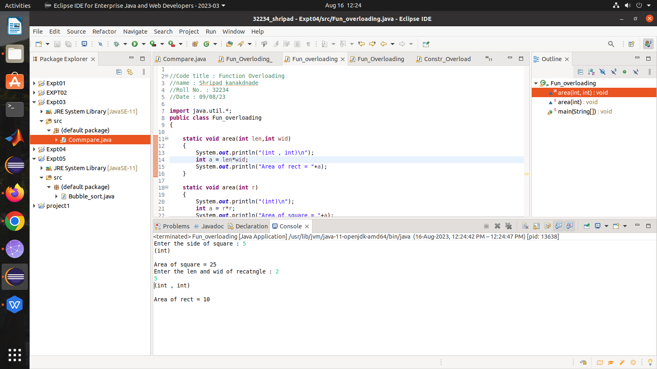

2]

//Code title : Function Overloading

//name : Shripad kanakdnade

//Roll No. : 32234

//Date : 09/08/23

**import** java.util.Scanner;

**public** **class** Fun_Overloading_2

{

**static** **void** area(**int** r)

{

System.***out***.println("(int)\n");

**int** a = r*r;

System.***out***.println("Area of square = "+a);

}

**static** **void** area(**double** r)

{

System.***out***.println("(double)\n");

**double** a = 2*3.14*r;

System.***out***.println("Area of circle = "+a);

}

**public** **static** **void** main(String[] args) {

// **TODO** Auto-generated method stub

Scanner sc = **new** Scanner(System.***in***);

System.***out***.print("Enter the side of square : ");

**int** n = sc.nextInt();

*area*(n); //Square

System.***out***.print("Enter the radius of circle : ");

**double** r = sc.nextDouble();

*area*(r); //Circle

}

}

**OUTPUT :**

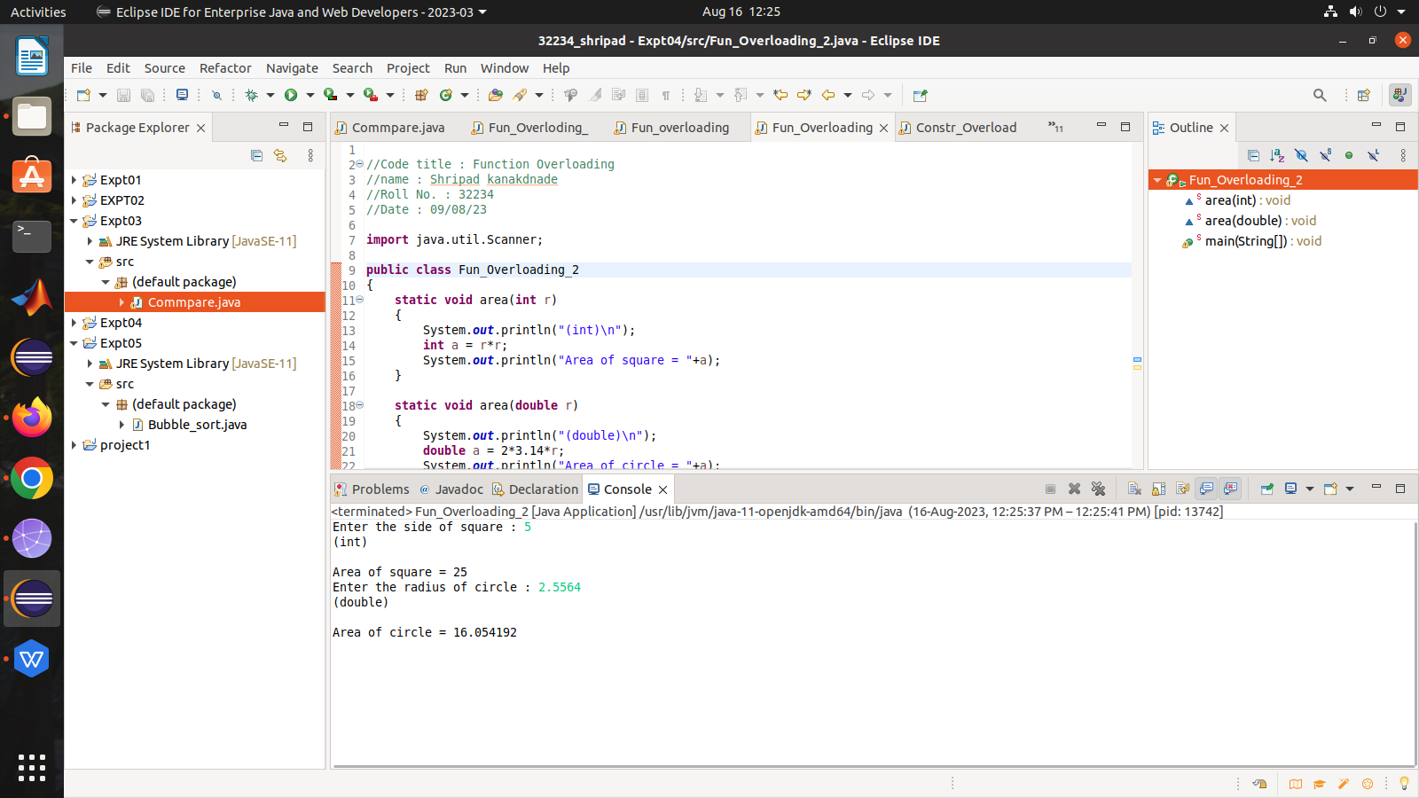

//Code title : Function Overloading

//name : Shripad kanakdnade

//Roll No. : 32234

//Date : 09/08/23

**import** java.util.Scanner;

**public** **class** Fun_Overloding_3

{

**static** **void** volume(**double** rad,**int** height)

{

System.***out***.println("(double , int)\n");

**double** vol = 3.14*rad*rad*height;

System.***out***.println("Volume of cylinder = "+vol);

}

**static** **void** volume(**int** height,**double** rad)

{

System.***out***.println("(int ,double)\n");

**double** vol = 3.14*rad*rad*height/3;

System.***out***.println("Volume of Cone = "+vol);

}

**public** **static** **void** main(String[] args)

{

// **TODO** Auto-generated method stub

Scanner sc = **new** Scanner(System.***in***);

System.***out***.print("Enter the rad and height of cylinder : ");

**double** r1 = sc.nextDouble();

**int** h1 = sc.nextInt();

*volume*(r1,h1);

System.***out***.print("Enter the rad and height of Cone : ");

**double** r2 = sc.nextDouble();

**int** h2 = sc.nextInt();

*volume*(h2,r2);

}

}

**OUTPUT :**

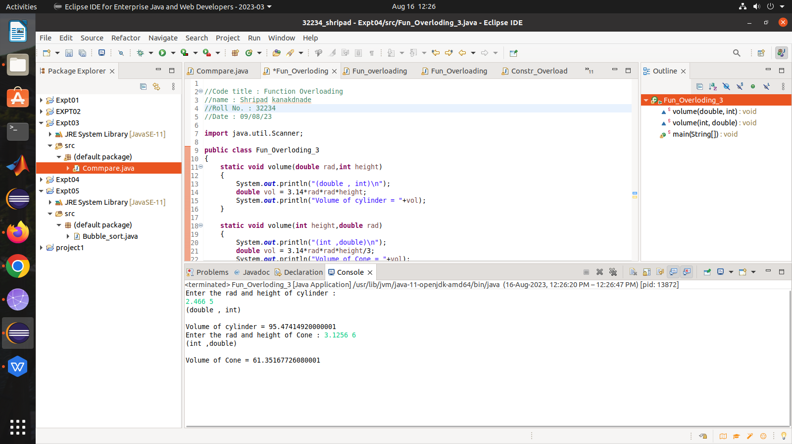

//Code title : Function Overloading

//name : Shripad kanakdnade

//Roll No. : 32234

//Date : 09/08/23

**import** java.util.*;

**public** **class** Constr_Overloading

{

String name;

**int** roll;

**double** CGPA;

Constr_Overloading()

{

System.***out***.println("In Default Constructor!");

System.***out***.println("name = "+name+"\nRoll no. = "+roll+"\nCGPA = "+CGPA);

}

Constr_Overloading(String name,**int** roll,**double** CGPA)

{

System.***out***.println("\nIn Parameterised Constructor!");

**this**.name = name;

**this**.roll = roll;

**this**.CGPA = CGPA;

System.***out***.println("name = "+name+"\nRoll no. = "+roll+"\nCGPA = "+CGPA);

}

**public** **static** **void** main(String[] args)

{

// **TODO** Auto-generated method stub

Constr_Overloading obj1 = **new** Constr_Overloading();

String name;

**int** roll;

**double** cgpa;

System.***out***.println();

Scanner sc = **new** Scanner(System.***in***);

System.***out***.print("Enter name : ");

name = sc.nextLine();

System.***out***.print("Enter Roll No. : ");

roll = sc.nextInt();

System.***out***.print("Enter CGPA : ");;

cgpa = sc.nextDouble();

Constr_Overloading obj2 = **new** Constr_Overloading(name,roll,cgpa);

}

}

**OUTPUT :**

